Chuanjie ZANG

699382953

Step 1 : Creating a new ai file and selecting 'fit artboard in windows' in 'view' creates a comfortable environment for me.

Step 2 : Select the 'star tool', hold down the left button and drag to draw the star, while keeping the left button pressed adjust the number of sharp corners of the star with the 'up' and 'down' arrow keys on the keyboard. The number of sharp corners here is the number of gears after that. I set the number to 12. The number of sharp corners here is the number of teeth of the subsequent gear.

Step 3 : Select the 'Direct Selection Tool' and click on the star, then drag the live corner inwards to make the star look like a gear.

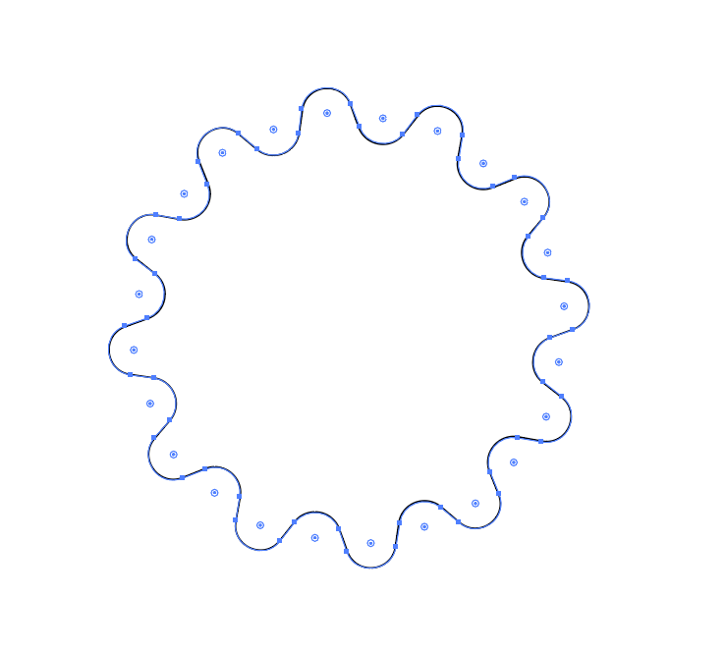

Step 4 : Next click on 'corners' in the 'control bar' above and select the third 'chamfer' after corners to make the graphic more like a mechanised gear.

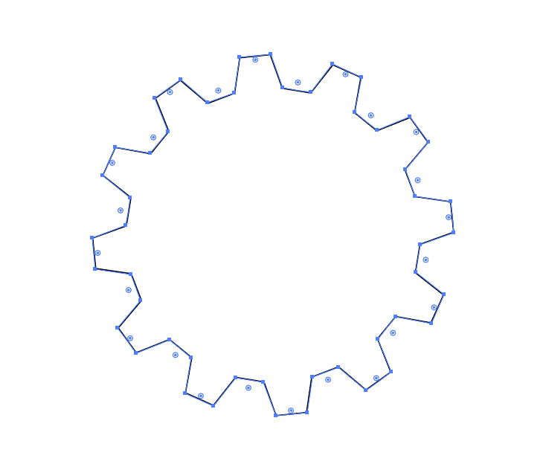

Step 5 :Use the 'ellipse tool' and hold down the 'shift' key to draw a circle

Step 6 :Use the 'ellipse tool' and hold down the 'shift' key to draw a circle. Place the circle in the middle part of the gear and hold 'shift' to resize the circle.

Step 7 : When the circle is the right size, use the 'Selection Tool' to frame the gear and the circle, followed by the 'control bar' or 'object - align'. Select horizontal align center' and 'vertical align center'. Finally use minus front in pathfinder to subtract the rounded area in the gear.

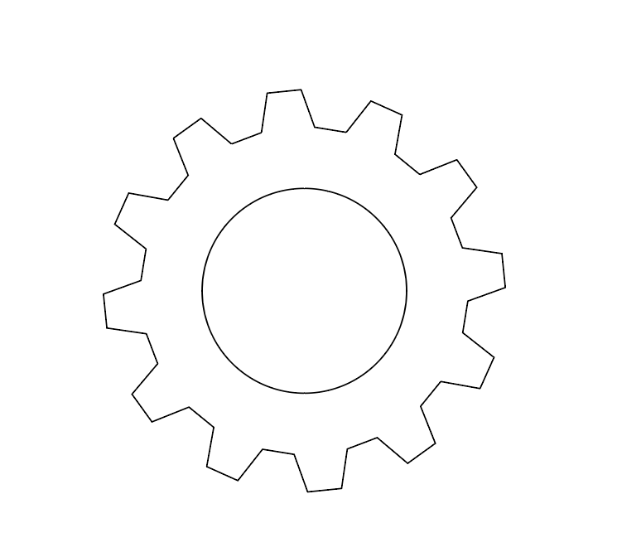

Step 8 : Next I need to draw the background (the circular pattern under the gears), in order not to interfere with the subsequent work, click on the right side of the "Layers Panel", click on the "Layer 1" on the left side of the arrow to show the gear layer, double-click to open the gear layer of the "Options" and then remove the tick in front of the "Show", and on the "Lock" tick.

Step 9 : Using the "Ellipse Tool", hold down the "shift" key to draw a circle; click the icon with three dots in the lower right corner of the "Properties Panel - Transformations" on the right side to expand the "Transformations Panel". Mouse over "Ellipse Width" and use the scroll wheel to adjust the number, or just type in the number to adjust the diameter of the circle. Here I have set the diameter to 600 for ease of manipulation, as the size of shapes drawn by dragging the mouse tends not to be an integer.

Step 10 : Use the Rectangle tool to draw a rectangle in the free area next to the circle, making sure the height of the rectangle is greater than the radius of the circle for ease of manipulation.

Step 11 : Use the Selection Tool to select the rectangle and set the value of Transform - Width in the Properties Panel on the right to 600 so that the rectangle has the same diameter as the width circle.

Step 12 : Use the Selection Tool to select the rectangle and set the value of Transform - Width in the Properties Panel on the right to 600 so that the rectangle has the same diameter as the width circle.

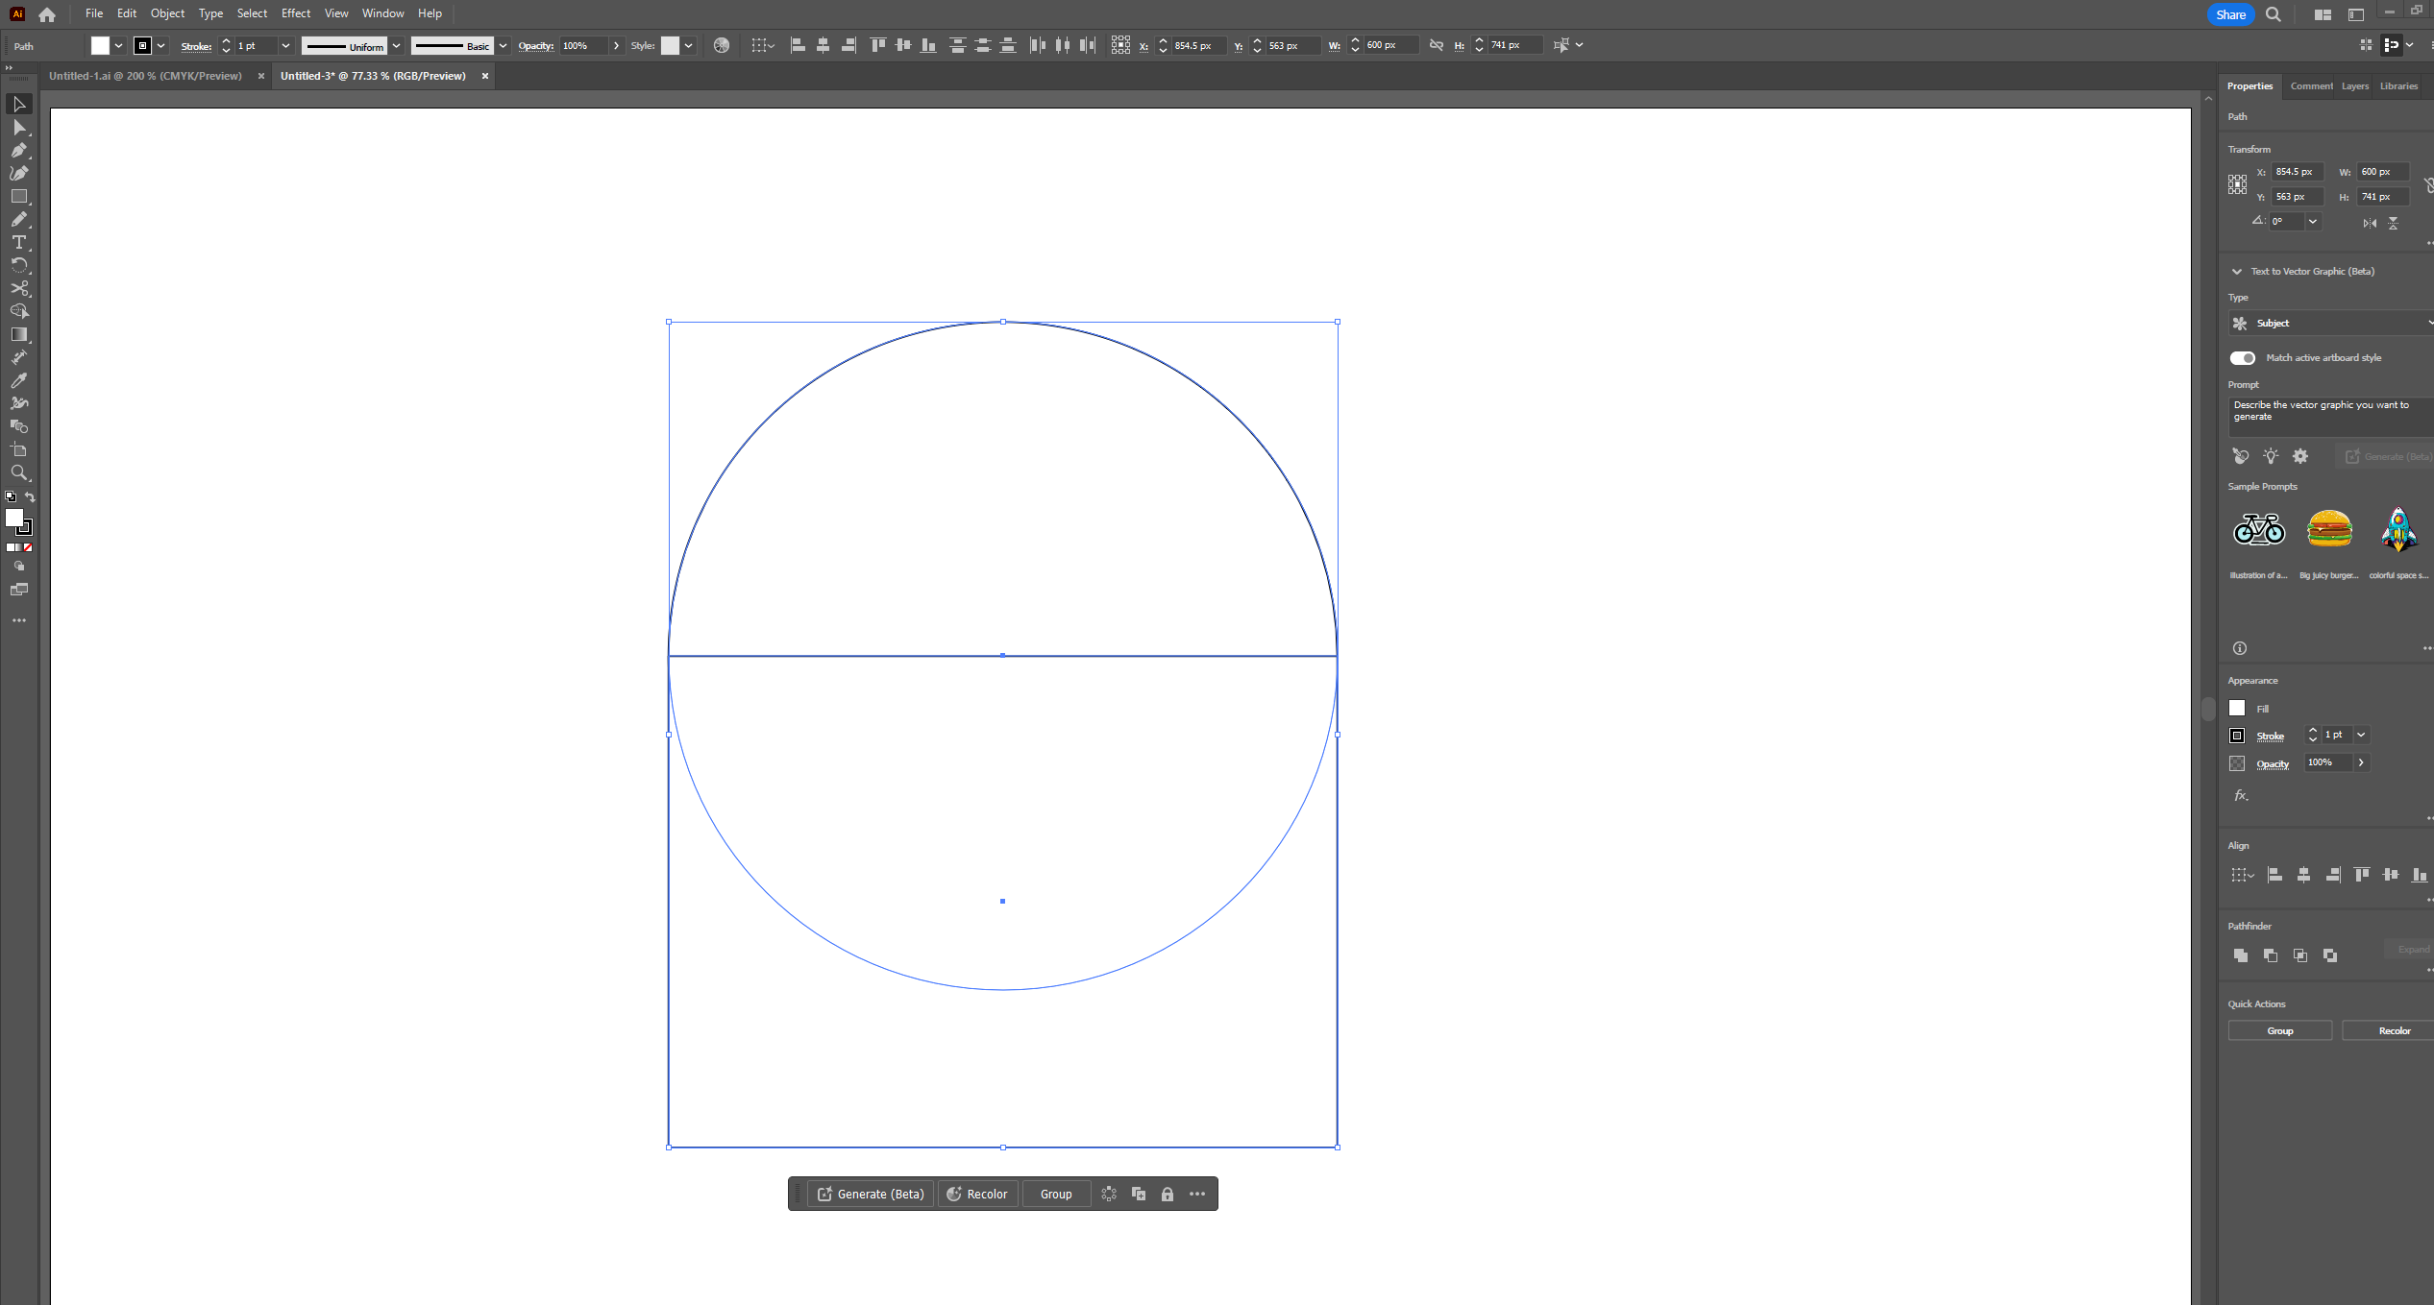

Step 13 : Use the 'Selection Tool' to box in all circles and rectangles, then use the 'Shape builder' to set the parts outside the circle as separate shapes.

Step 14 : Delete the outer part of the circle, then group the rest of the circle and adjust 'rotate' in the right-hand 'Properties Panel' to rotate the whole shape to the right angle, I've set the angle to 40 here.

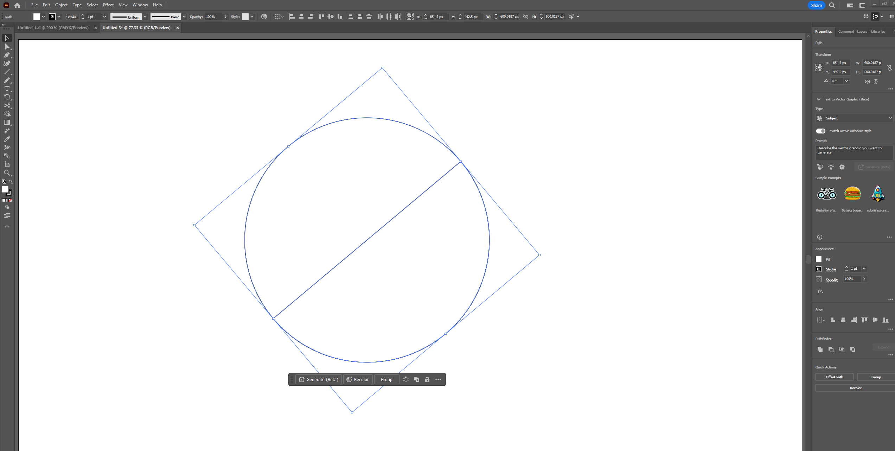

Step 15 : Ungroup the entire graph and use the 'Selection Tool' to select one of the graphs. Next set the colours for each graphic individually.

Step 16 : On the right hand side, in 'layers', 'show' the layer of the gears and unlock it. Then drag the gear layer on top of the other layers.

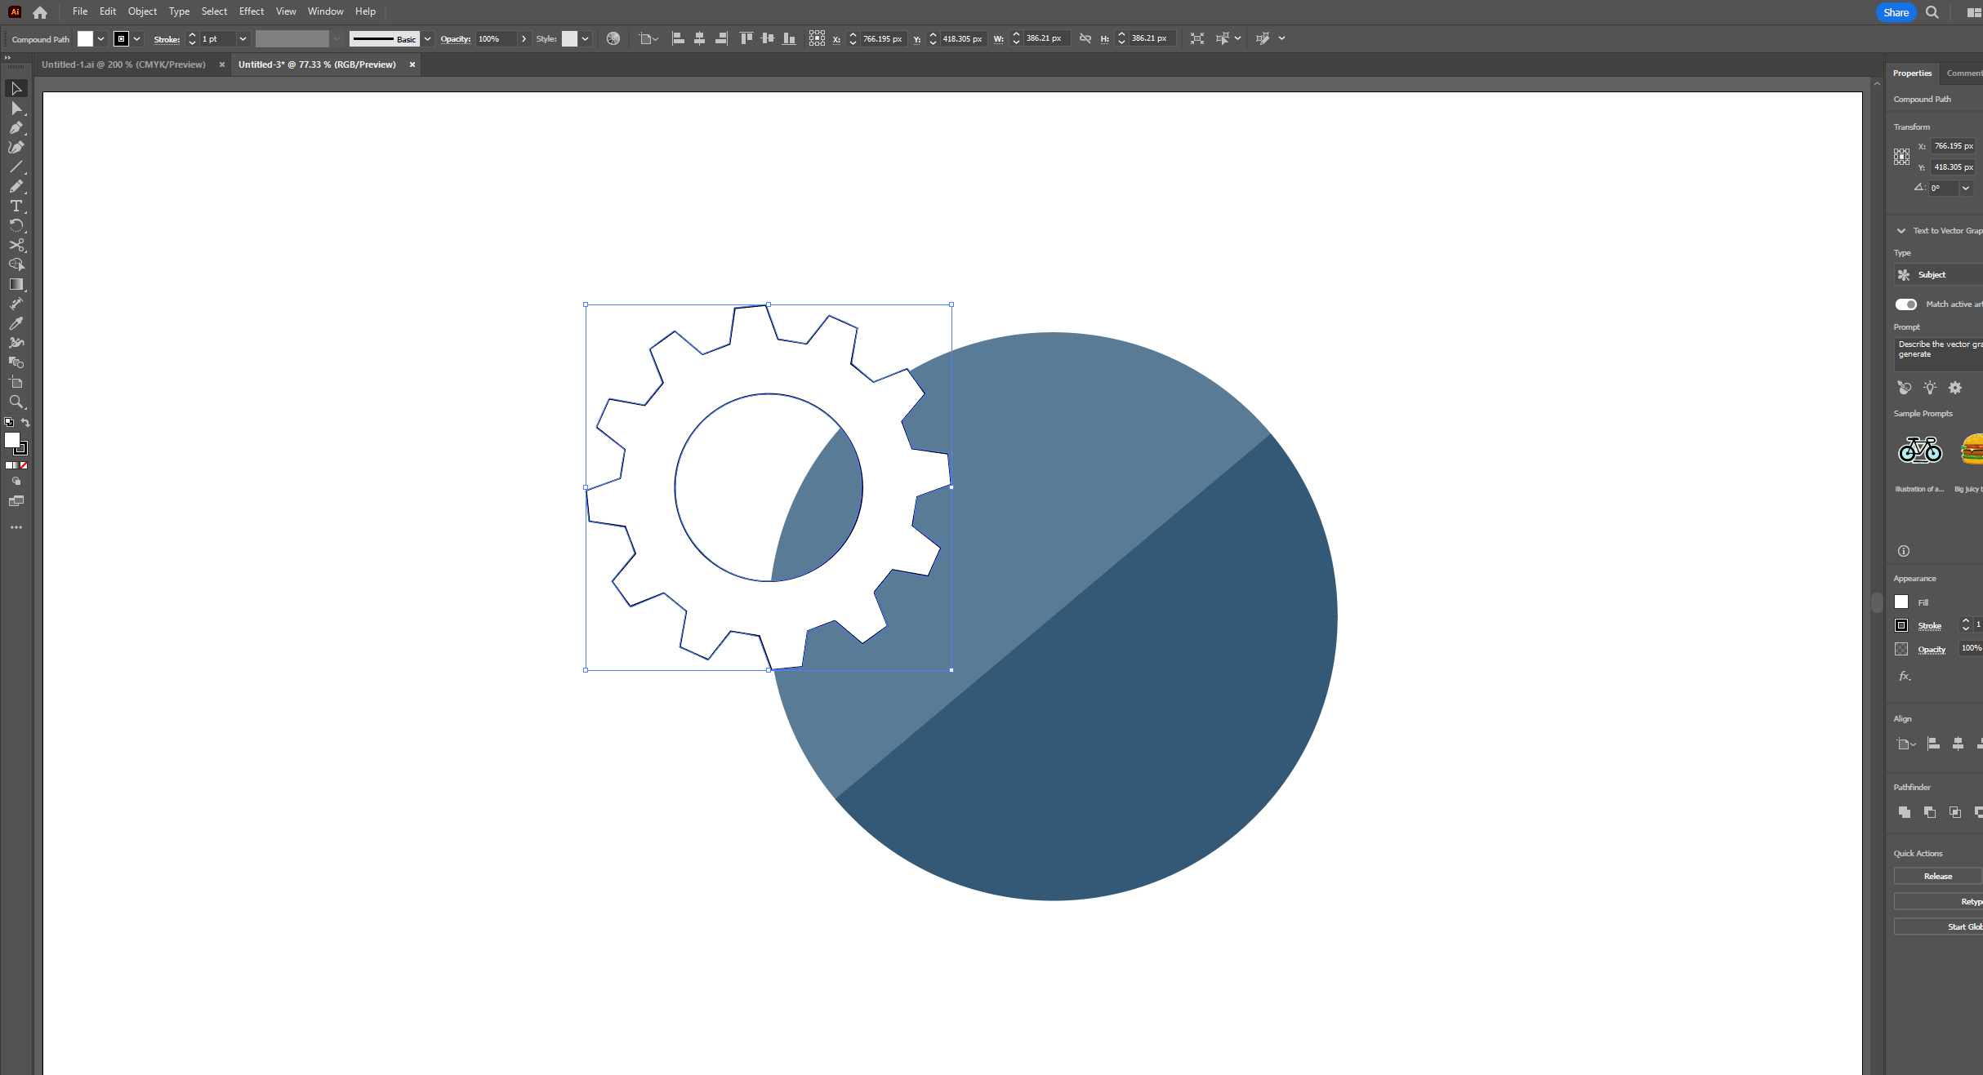

Step 17 : First 'group' the entire circular section, then use the 'Selection Tool' to frame the gears and the circular pattern, using 'Horizontal & Vertical Align Center'. Hold down 'shift' to resize the pattern to your needs and sing 'Horizontal & Vertical Align Center' to finish.

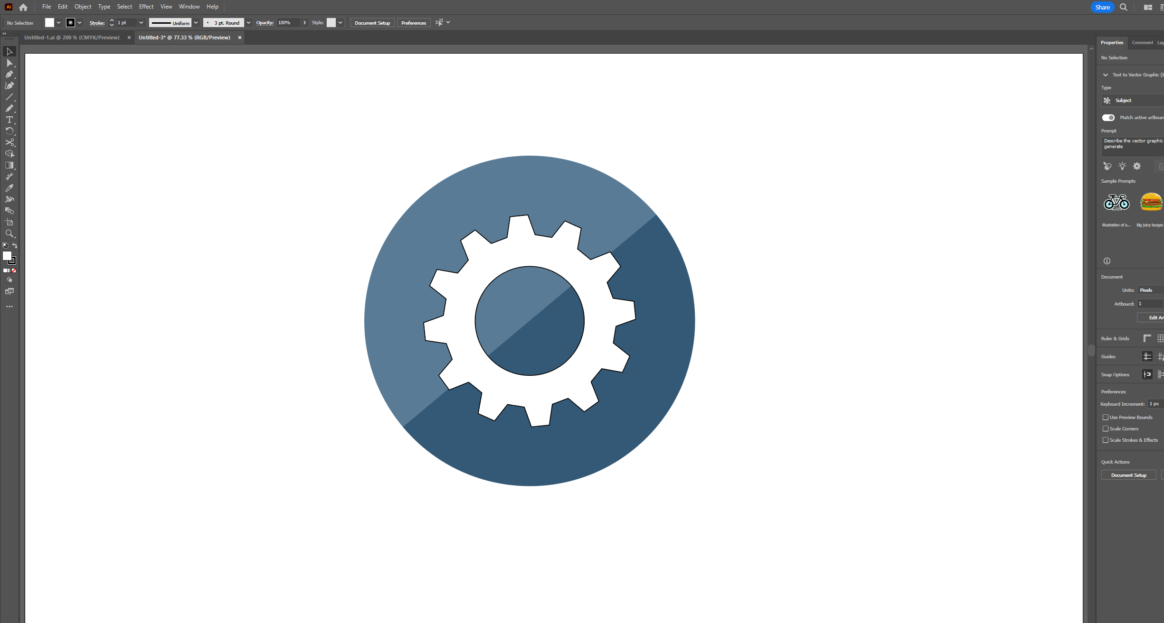'

Step 18 : Use the 'Rectangle Tool' to draw a rectangle, set the angle to 40, set the transparency to 65%, set the layer above the gears, and adjust the width to be the same as the width of the gears. The transparency is adjusted to make it easier to align with the corners of the gear.

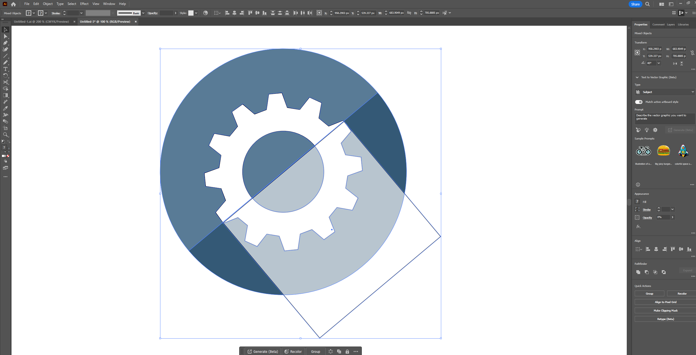

Step 19 : Use the 'selection tool' to frame the entire pattern, and then use the 'shape builder' to set the area of the transparent part that does not overlap the circle as a separate pattern before deleting this part. Then set the colour of this transparent area and turn the transparency back to 100%, then place this layer below the gears and above the circle.

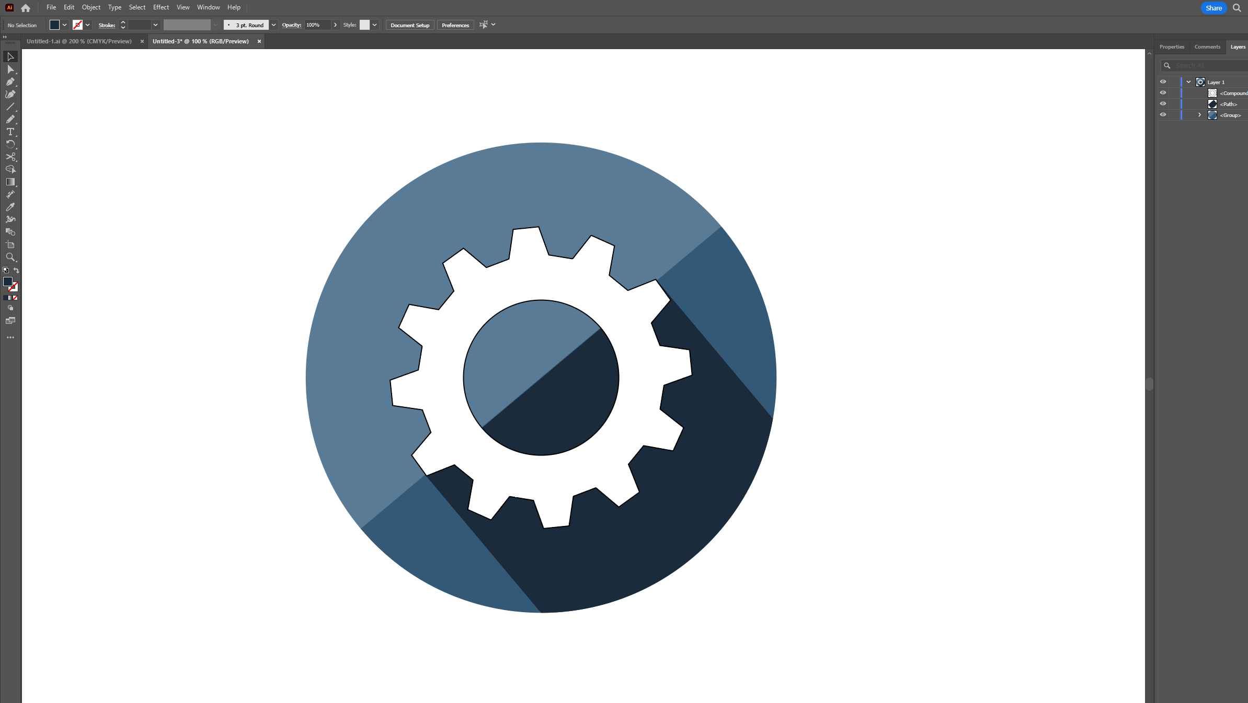

Step 20 : Use the 'Selection Tool' to box in all the patterns and ungroup, then use the 'Rectangle Tool' to draw a rectangle and adjust the angle and transparency, followed by aligning it with the top left part of the gear. This step is to add more shadow to the gear. Repeat this step until the entire area to be shadowed is covered. In order to make the shadow conform to the angle of the gears, this process involves selecting only the gears and the shadow and using the Shape Builder tool to remove the corner areas.

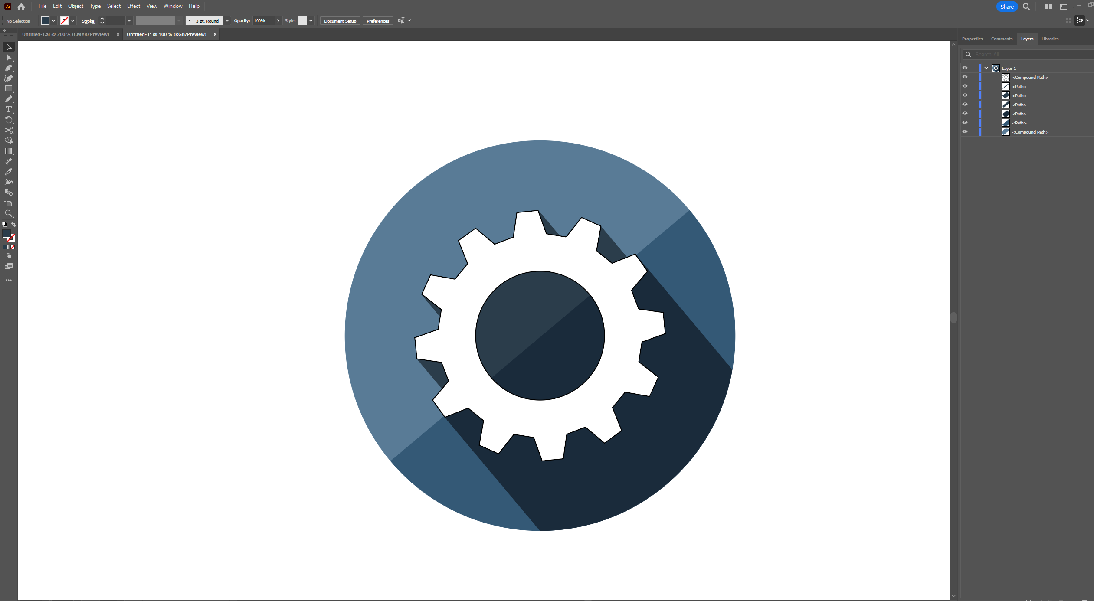

Step 21 : If necessary I can consolidate several pieces of the gear's shadows on the left half of the circle into one shape using 'pathfinder - unite' to make it easier to adjust the whole graphic later. To make it easier to adjust later, I first duplicated and hid & locked these fragmented shadow shapes, then merged the shadowed areas under the gear into one shape. Then name it 'backup - shadow left'

Step 22 : I did not remove the gear strokes from the graphic for reasons of preserving the mechanical aesthetic. But the strokes in the background strokes outside the gears I removed.